

Insert Company Message

Hosted by: Insert Company Name

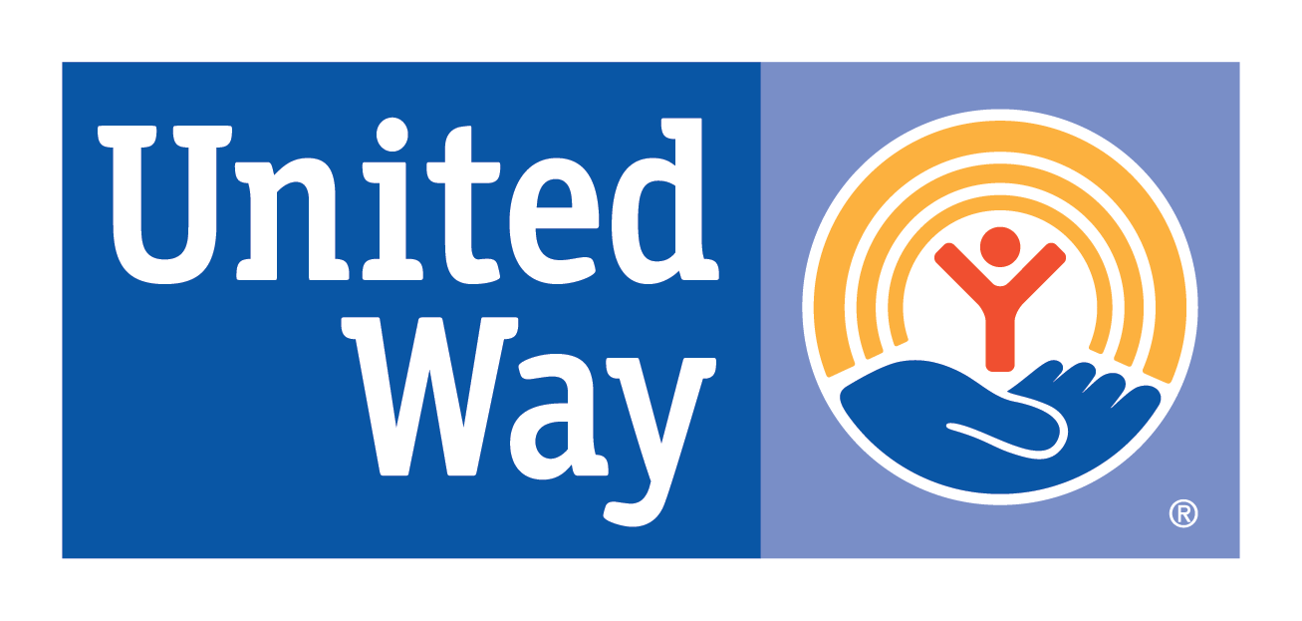

April showers bring May flowers... or in this case April showers bring

happy mommies to be!

Many families struggle to get from paycheck to paycheck and seek help from local programs including area food pantries, shelters and Rebecca’s Closet. April is a great month to help by donating most needed baby items. Donate new or gently used items to:

**United Way**

**of Marathon County**

**Items collected will be distributed through:**

* Bundles of Joy
* Rebecca’s Closet
* Area Food Pantries
* Local Shelters
* And other organizations serving low-income families

**Most needed items:**

* Diapers
* Baby Wipes
* Onesies (3mo-24mo)
* Sleepers (Newborn-24mo)
* Receiving Blankets
* Crib Sheets
* Crib Mattress Pads
* Infant Bath Towels

**New or gently used:**

* Strollers
* High Chairs
* Bouncers
* Rock n ‘Plays
* Pack n ‘Plays
* Infant Bath Tubs

*We cannot accept used cribs or car seats*